I had a first-gen iPad as a kid, back in 2009. I recently discovered it, and it was a time machine. I remembered all the apps, Need for Speed Shift, Need for Speed Hot Pursuit, Need for Speed Most Wanted, The original Angly birds, Tap tap 4, The VW group challenge games, the Mercedes SLS games, BMW magazine, Bentley magazine, Top Gear Magazine, VW Magazine, Mercedes Magazine, Paper Toss 2, the original Talking Tom, Pac Man, and so, so so, much more. It was so beautiful, and I really loved that machine as a kid. It was the first gen, thick, no cameras, big bezels, but so damn cool. You could just touch the screen, and the screen would register a press! No lag here, even on Apple’s A4. My A15 phone lags a lot more than this thing.

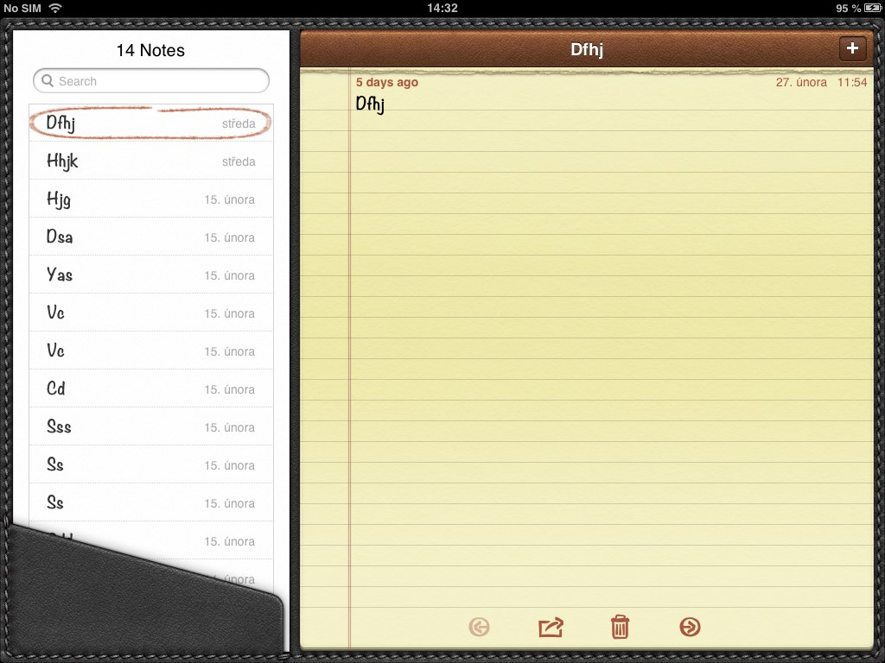

Now it looks like freakin this-
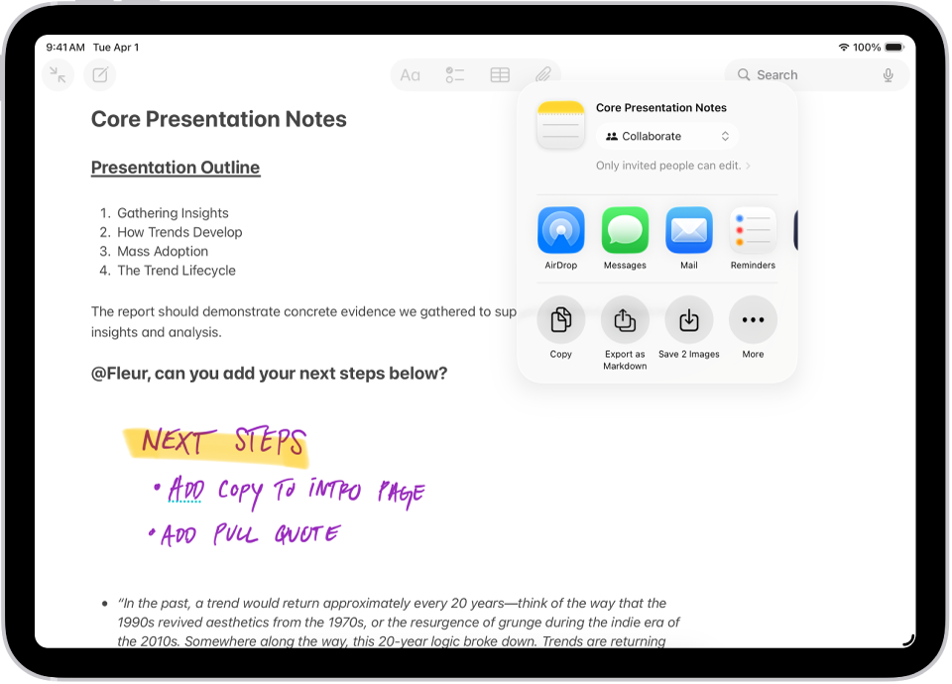
It’s my class 12 Computer Science project. After last year’s lackluster menu-driven program, I decided to go (comparatively) big or go home. I wanted to create 1% of my childhood memories. A skeuomorphic notes app. Outdoing even Apple’s iOS 5. It's built in Python, with a GUI and MySQL connectivity.
I took tiny images of a handwritten version of every Single typable function on the keyboard. Then I resized them using an online resizer to 16 x 16 pixels. Then I mapped every key press to a corresponding image, snapped a background picture, and started coding to position the photos naturally. It was tough, and this unfinished version is version 9. This version 9 has AI baked into the variable names. I also used it to fix errors, and I learned a lot from it, too, because I’d barely heard of GUIs before attempting this project.

Here’s a screenshot-
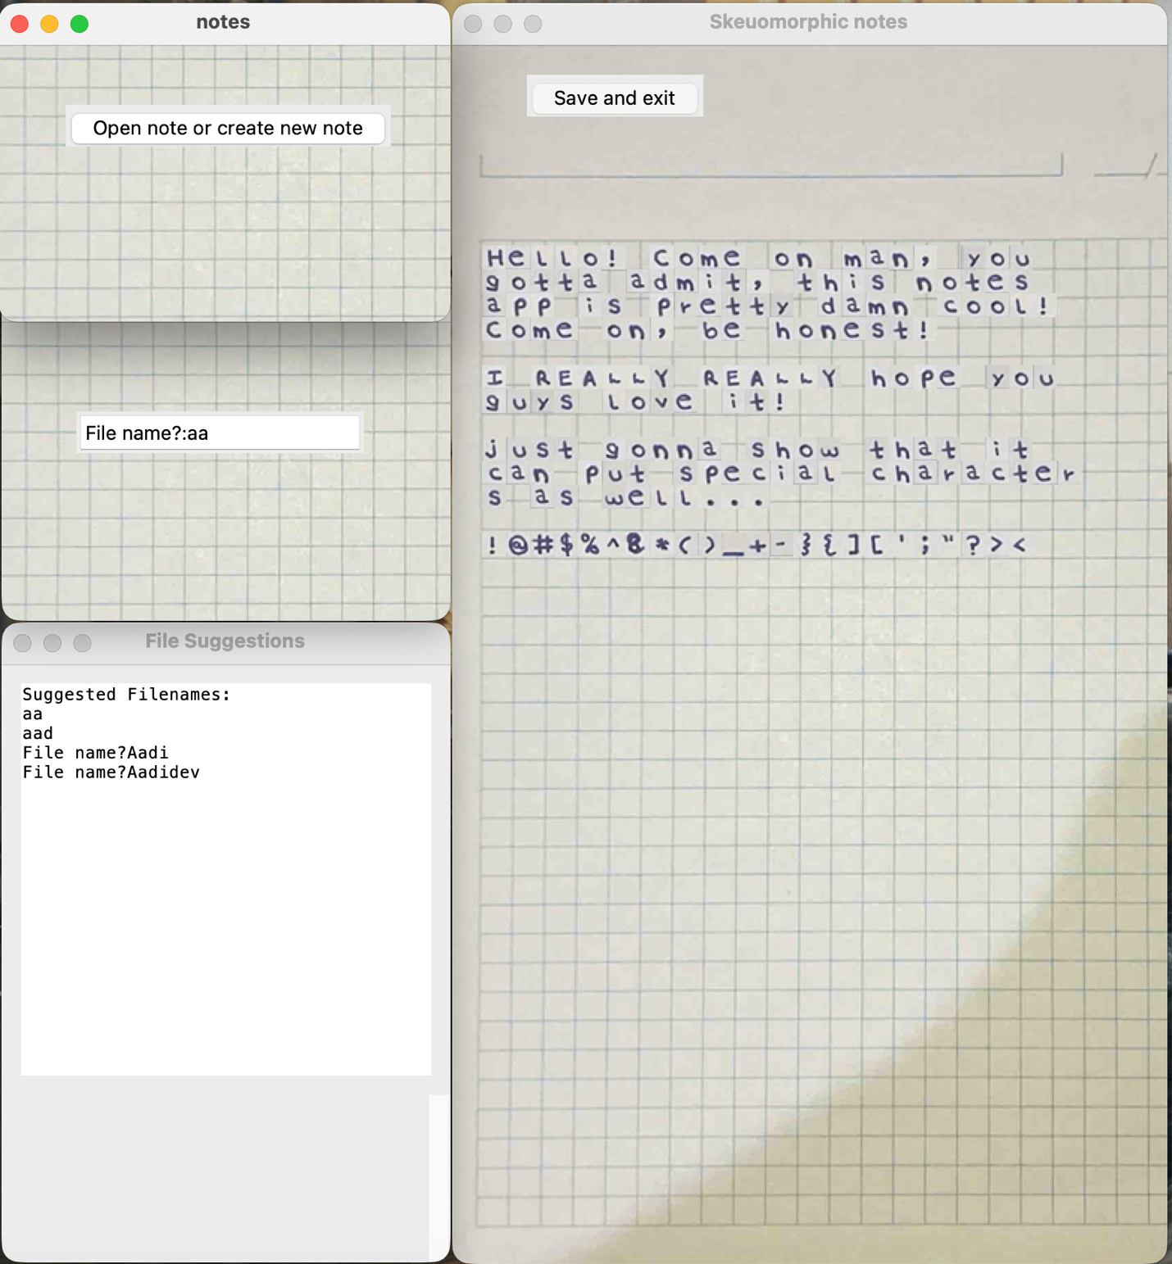
I think it’s pretty impressive (because it was SO difficult to code), but I donno, what do you guys think?
Anyway, the way the file suggestions window works is pretty weird. I’ll fix it in public release V2. So when you type a file name initially, if the file name doesn’t exist, it creates a new file with that name. Once you click enter, it’ll display similar file names. Let’s say you wanted to open an Aadi file but typed 'a' and pressed Enter. It’ll create a new file named a. Then you see the file suggestions, and be like, OH, the document was Aadi!, and then close the main Skeuomorphic notes window without saving and exiting. The file suggestions window remains open, and you type the correct file name.
The file is saved as (whatever you typed) + ‘.txt’ for copying and pasting later on.
To run it, you’ll need MySQL, as the file-suggestion window uses case insensitivity. In it, type these commands-
create database project;
use project;
create table proj(Filename varchar(555) primary key);

Also, within the MySQL connectivity code, you needa enter your database and password details.

I know this is a different style of README, but I don’t think you wanna be bothered with 5 pages of literally the same thing, but more ‘professional’.

Thanks, dudes and dudettes
Feel free to fork it, improve it, break it, or just explore the code.
I hope you enjoy it as much as I enjoyed building it. You guys are better than me at this stuff, so if you have any improvements, please, send it

